**PRJ301 Project**

**PerfumePod Web**



Student: Nghiem Thi Hong Ngoc

Lecturer: Do Thi Loan

Subject: PRJ301

Class: SE1812

# Preamble

Nowadays, e-commerce is booming globally. Digital technologies help us save significant costs by cutting out intermediary shipping expenses, transaction fees, and, notably, by saving time, allowing individuals to have more time on other activities. Furthermore, e-commerce enables automatic searches for various purposes and delivers information tailored to individual needs and preferences. Now, people can conveniently shop from home for everything they desire, and online retail websites facilitate this. Hence, for my project in subject PRJ301, I have chosen to develop a web for the PerfumePod store, specializing in selling perfumes. The idea of choosing perfume as a selling product for my web project came from the coincidence that I saw an advertisement of perfume and I think perfume is a unique product category to sell (while others often make book store online, shoes shop online, etc…). Lastly, I want to thanks my PRJ301 lecturer LoanDT by teaching me the web making process basis so that I can build the web myself and my classmates who support me with the content of the web.

Table of Contents

Preamble 3

1. Theory 6

a. HTML 6

i. Overview 6

ii. Components 6

b. CSS 7

i. Overview 7

ii. Syntax 7

c. Javascript 7

i. Overview 7

ii. Components 8

d. Java 8

i. Overview 8

ii. Components 8

iii. Servlet 9

e. SQL Server 10

i. Definition 10

ii. Concepts 10

iii. Syntax 10

f. Bootstrap 11

g. Apache Netbeans 11

i. Concepts 11

ii. Projects made by Netbeans 11

h. Apache Tomcat 12

i. Concepts 12

ii. Supply 12

2. System Design 13

a. Function 13

b. Use Case Diagram 13

c. Class Diagram 17

d. Activity Diagram 17

e. Database Tables 19

i. Table Customers 19

ii. Table Admins 19

iii. Table Brands 19

iv. Table Categories 19

v. Table Perfumes 19

vi. Table CartDetails 20

vii. Table Orders 20

viii. Table OrderDetails 20

3. Website Design 20

a. Customer home interface 20

b. Search bar template 21

c. Customer login interface 21

d. Register interface 22

e. Search product interface 22

f. Product detail interface 23

g. Cart interface 23

h. Check out interface 24

i. Customer View Orders Interface 24

j. Customer profile interface 25

k. Customer change password interface 25

l. Admin login interface 26

m. Admin home interface 26

n. Admin manage order interface 27

o. Manager view statistic interface 27

p. Manager manage staffs interface 28

q. Manager add staffs interface 28

r. Admin add perfume interface 29

s. Admin add brand interface 29

Conclusion 30

References 30

# Theory

## HTML

### Overview

-HTML stands for Hyper Text Markup Language

-HTML is the standard markup language for creating Web pages

-HTML describes the structure of a Web page

-HTML consists of a series of elements

-HTML elements tell the browser how to display the content

-HTML elements label pieces of content such as "this is a heading", "this is a paragraph", "this is a link", etc.

### Components

The <!DOCTYPE html> declaration defines that this document is an HTML5 document

*Elements:*

-The <html> element is the root element of an HTML page

-The <head> element contains meta information about the HTML page

-The <title> element specifies a title for the HTML page (which is shown in the browser's title bar or in the page's tab)

-The <body> element defines the document's body, and is a container for all the visible contents, such as headings, paragraphs, images, hyperlinks, tables, lists, etc.

-The <h1> element defines a large heading

-The <p> element defines a paragraph

-The image tag <img>: Allows you to insert images into a webpage.

-The anchor tag <a>: This type of tag is used to create links between web pages or links to Internet, email, or Intranet addresses (URLs), and addresses within files on a local network (UNC).

-Input tags: Input tags allow users to input data or specify the execution of an action. Input tags include various types such as: text, password, submit, button, reset, checkbox, radio, image.

-The Select tag: The Select tag allows users to choose elements from a predefined set of options. If the Select tag allows users to select one element from the list of options, it functions similar to a combobox. If the Select tag allows users to select multiple elements at once from the list of options, it functions as a listbox.

-The Form tag: When you want to submit data entered by users on a webpage from the client side to the server side, you have two methods corresponding to the POST and GET methods within the form tag. A web page can contain multiple different form tags, but these form tags should not be nested within each other. Each form tag is declared with an action attribute pointing to a different page.

## CSS

### Overview

-CSS stands for Cascading Style Sheets

-CSS describes how HTML elements are to be displayed on screen, paper, or in other media

-CSS saves a lot of work. It can control the layout of multiple web pages all at once

-External stylesheets are stored in CSS files

### Syntax

-A CSS rule consists of a selector and a declaration block.

-The selector points to the HTML element you want to style.

-The declaration block contains one or more declarations separated by semicolons.

-Each declaration includes a CSS property name and a value, separated by a colon.

-Multiple CSS declarations are separated with semicolons, and declaration blocks are surrounded by curly braces.

-Example:

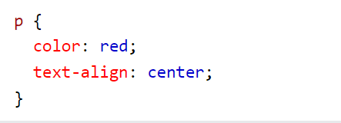

Explain:

-p is a selector in CSS (it points to the HTML element you want to style: <p>).

-color is a property, and red is the property value

-text-align is a property, and center is the property value

## Javascript

### Overview

JavaScript is a scripting language that enables you to create dynamically updating content, control multimedia, animate images, and pretty much everything else.

JavaScript syntax is similar to other programming languages like Java and C++, making it relatively easy for developers to learn. It supports both procedural and object-oriented programming paradigms.

### Components

-Variables and Data Types: Variables are used to store data in JavaScript. Common data types include numbers, strings, booleans, objects, and arrays.

-Functions: Functions are blocks of reusable code. In JavaScript, functions can be defined using the function keyword.

-Events: JavaScript allows you to respond to events on a webpage, such as user actions or changes in the document.

-DOM (Document Object Model): JavaScript interacts with the DOM, which represents the structure of a web document as a tree of objects. This interaction allows dynamic manipulation of the content and structure of a webpage.

## Java

### Overview

-Java is a high-level, class-based, object-oriented programming language.

-It was developed by James Gosling and Mike Sheridan at Sun Microsystems and released in 1995.

-Java applications are designed to be platform-independent, meaning they can run on any device with a Java Virtual Machine (JVM).

### Components

-A Java program is typically organized into classes, and each class can have methods, fields, and constructors.

-The entry point of a Java program is the **main** method.

-Java follows the principles of object-oriented programming (OOP), including encapsulation, inheritance, and polymorphism.

-Classes and objects are fundamental concepts in Java programming.

-Java Standard Edition (SE) and Enterprise Edition (EE):

+Java SE provides the core functionality of the Java programming language.

+Java EE extends Java SE with specifications for enterprise features such as distributed computing and web services.

### Servlet

Servlets are Java-based components that extend the capabilities of a server to generate dynamic content and interact with clients, typically web browsers. Servlets are part of the Java Platform, Enterprise Edition (Java EE), which is now known as Jakarta EE.

*-Servlet Life Cycle:*

+Initialization: The servlet container (such as Tomcat or Jetty) loads the servlet and calls its init() method.

+Request Handling: The servlet handles client requests by processing the service() method for each request.

+Destruction: When the servlet container decides to unload the servlet (usually during shutdown), it calls the destroy() method.

*-Servlet API:*

+Servlets are part of the Java EE specification and use the jakarta.servlet package.

+The core interfaces include Servlet and ServletConfig, and the main classes are GenericServlet and HttpServlet.

+HttpServlet is particularly useful for handling HTTP-specific requests (GET, POST, etc.).

Request and Response Handling:

+Servlets can read client data through the HttpServletRequest object and send data back to clients through the HttpServletResponse object.

+They can handle different types of requests (GET, POST, etc.) by overriding the corresponding methods like doGet() and doPost().

*-Servlet Mapping:*

Servlets are typically mapped to specific URL patterns in the deployment descriptor (web.xml or using annotations in modern servlet APIs).

This mapping is done to specify which servlet should handle requests for a particular URL.

*-Session Management:*

Servlets can manage user sessions using the HttpSession object, which allows the storage of session-specific information across multiple requests.

*-Servlet Filters:*

Filters can be applied to servlets to perform tasks such as logging, authentication, and input validation before the request reaches the servlet or after the response leaves the servlet.

## SQL Server

### Definition

SQL Server is a relational database management system (RDBMS) developed by Microsoft. It's widely used for storing and retrieving data in various applications, from small businesses to large enterprises.

### Concepts

-Editions: SQL Server comes in several editions, including Express (free), Standard, Enterprise, and Developer. Each edition has its own set of features and limitations.

-Components: SQL Server includes several components such as Database Engine, Integration Services (SSIS), Analysis Services (SSAS), Reporting Services (SSRS), and more. These components cater to different aspects of data management, analysis, and reporting.

-Transact-SQL (T-SQL): SQL Server uses Transact-SQL, an extension of SQL, as its query language. T-SQL provides additional features and functionality beyond standard SQL, such as procedural programming constructs, error handling, and more.

-Management Tools: SQL Server provides various management tools for administering databases, such as SQL Server Management Studio (SSMS) for graphical administration, SQL Server Data Tools (SSDT) for development, SQL Server Configuration Manager for configuring server settings, and SQL Server Profiler for monitoring and analyzing database activity.

### Syntax

- SQL (Structured Query Language) is used to communicate with and manipulate databases. SQL Server syntax elements:

+ SELECT Statement: Used to retrieve data from a database.

+ INSERT Statement: Used to insert new records into a table.

+ UPDATE Statement: Used to update existing records in a table.

+ DELETE Statement: Used to delete records from a table.

+ CREATE TABLE Statement: Used to create a new table in the database.

+ ALTER TABLE Statement: Used to modify an existing table (e.g., add or drop columns).

+ DROP TABLE Statement: Used to delete a table from the database.

+ JOIN Clause: Used to combine rows from two or more tables based on a related column between them.

+ WHERE Clause: Used to filter records based on a specified condition.

+ ORDER BY Clause: Used to sort the result set in ascending or descending order.

+ GROUP BY Clause: Used to group rows that have the same values into summary rows.

+ HAVING Clause: Used to filter group rows after the GROUP BY clause.

## Bootstrap

-Bootstrap is an HTML, CSS, and JavaScript framework that allows users to easily design websites according to a specific standard, creating mobile-friendly websites for devices such as mobile phones, iPads, and tablets.

-Bootstrap includes basic elements such as typography, forms, buttons, tables, navigation, modals, image carousels, and more. Within Bootstrap, there are additional components and JavaScript support for designing your responsive layouts more easily, conveniently, and quickly.

-Bootstrap is one of the most widely used frameworks globally for building websites. -Bootstrap has established its own standard and is highly favored by users. Therefore, we often hear a very common phrase "Design according to Bootstrap standards."

-From this "standard," we can clearly see the advantages of using Bootstrap:

+Easy to use: It's simple because it's based on HTML, CSS, and JavaScript. With basic knowledge of these three, you can use Bootstrap effectively.

+Responsive: Bootstrap provides pre-built responsive CSS for devices such as iPhones, tablets, and desktops. This feature saves users a lot of time in creating a website that is friendly to electronic devices and handheld devices.

+Browser compatibility: It is compatible with all browsers (Chrome, Firefox, Internet Explorer, Safari, and Opera). However, for IE browser, Bootstrap only supports IE9 and above. This is easy to understand because IE8 does not support HTML5 and CSS3.

## Apache Netbeans

### Concepts

Apache NetBeans is an open-source integrated development environment (IDE) primarily used for Java development, but it supports multiple programming languages such as PHP, HTML5, and C/C++ through plugins.

### Projects made by Netbeans

-Java Desktop Applications: Develop desktop applications using Java Swing or JavaFX. You can create applications like text editors, image viewers, media players, or even simple games.

-Web Applications: Build web applications using Java EE technologies such as Servlets, JSP, and JavaServer Faces (JSF). Apache NetBeans provides support for web development, making it easy to create dynamic web applications.

-Database Applications: Create database applications using Java Database Connectivity (JDBC) to connect to databases like MySQL, PostgreSQL, or Oracle. You can develop applications for data entry, management, and reporting.

-Mobile Applications: Develop mobile applications using Java ME (Micro Edition) or JavaFX Mobile. You can create simple mobile games, utility apps, or even enterprise applications for mobile devices.

-Enterprise Applications: Build enterprise applications using Java EE technologies such as Enterprise JavaBeans (EJB), Java Persistence API (JPA), and Java Message Service (JMS). Apache NetBeans provides tools for enterprise development, including support for application servers like Apache Tomcat, GlassFish, and WildFly.

-Web Services: Create RESTful web services or SOAP-based web services using Apache NetBeans. You can build backend services for mobile apps, web applications, or integrate with other systems.

-Plugin Development: Develop plugins for Apache NetBeans to extend its functionality. You can create custom tools, code generators, or integrate with external APIs and services.

-Game Development: Build simple games using Java and libraries like JavaFX or Lightweight Java Game Library (LWJGL). Apache NetBeans provides a development environment for game development, including code editing, debugging, and deployment.

-Data Analysis and Visualization: Use Apache NetBeans for data analysis and visualization projects. You can import data from various sources, perform analysis using libraries like Apache Commons Math or Weka, and visualize the results using charts or graphs.

-Educational Projects: Develop educational projects such as quiz apps, e-learning platforms, or student management systems using Apache NetBeans. You can create interactive learning experiences for students or tools for teachers to manage their classes.

## Apache Tomcat

### Concepts

Apache Tomcat is an open-source web server and servlet container developed by the Apache Software Foundation. It implements several Java EE specifications including Java Servlet, JavaServer Pages (JSP), WebSocket, and Java Expression Language (EL), providing a robust platform for deploying Java-based web applications.

### Supply

+Servlet Container: Apache Tomcat serves as a servlet container, which means it provides an environment for executing Java Servlets and managing their lifecycle. Servlets are Java classes that extend the functionality of a web server to generate dynamic web content.

+JSP Support: Tomcat supports JavaServer Pages (JSP), a technology that allows developers to embed Java code into HTML pages. JSP pages are compiled into servlets by Tomcat, enabling dynamic content generation and easier web development.

+Java EE Compatibility: While Tomcat is not a full Java EE application server like JBoss or WebLogic, it supports many Java EE specifications and APIs, making it suitable for deploying lightweight Java web applications. It provides support for features like JNDI (Java Naming and Directory Interface), JDBC (Java Database Connectivity), JTA (Java Transaction API), and more.

+WebSocket Support: Apache Tomcat includes support for WebSocket, a communication protocol that enables full-duplex communication channels over a single TCP connection. This allows for real-time, bi-directional communication between the client and server, making it suitable for applications that require low-latency communication, such as online gaming, chat applications, and real-time collaboration tools.

+Security Features: Tomcat provides various security features to protect web applications from common vulnerabilities such as cross-site scripting (XSS), cross-site request forgery (CSRF), and injection attacks. It supports features like SSL/TLS encryption, HTTP/HTTPS redirection, access control, and authentication mechanisms.

+Embeddable: Apache Tomcat can be embedded within other Java applications, allowing developers to package and deploy web applications as part of a standalone Java application. This is useful for scenarios where a lightweight, self-contained web server is needed, such as in microservices architectures or embedded systems.

+Scalability and Performance: Tomcat is designed for scalability and high performance, with features like connection pooling, thread pooling, and clustering support. It can handle a large number of concurrent connections and scale horizontally by deploying multiple instances behind a load balancer.

+Administration and Monitoring: Tomcat provides management tools for administering and monitoring the server and deployed applications. It includes a web-based administration console, command-line tools, and JMX (Java Management Extensions) support for monitoring server metrics and performance.

# System Design

## Function

*-Customer*

+Register

+Login/Log out/Edit profile

+Search products

+Create/view/update/cancel Cart

+Check out

+Create/view/ cancel order

*-Staff/Manager*

+Login/Log out

+Search

+Store items

+Process (view, update, cancel) order

+View statistics of item selling (Manager)

+Manage staff: add, delete, promote (Manager)

## Use Case Diagram

*-Main diagram:*

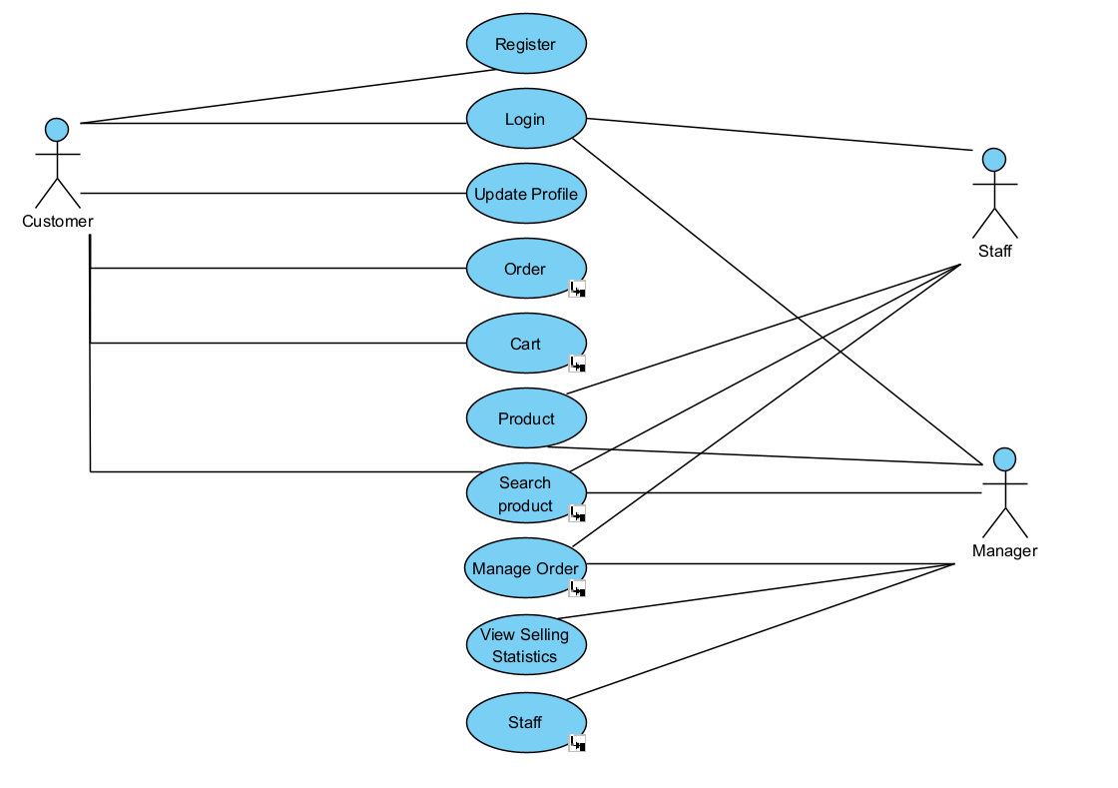

*-Sub-diagrams:*

+Order use case diagram:

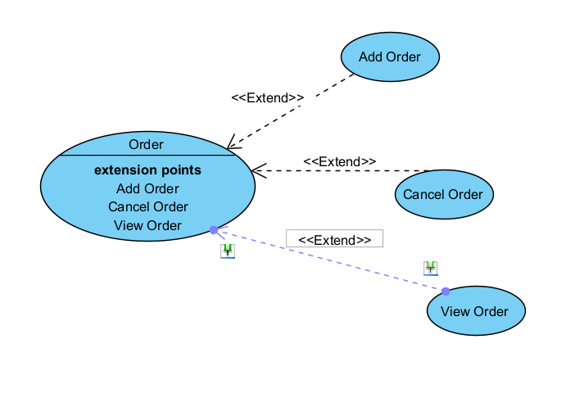

-Cart use case diagram:

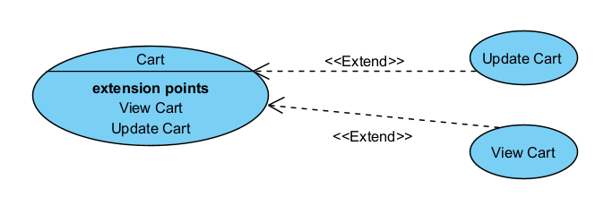

+Search use case diagram:

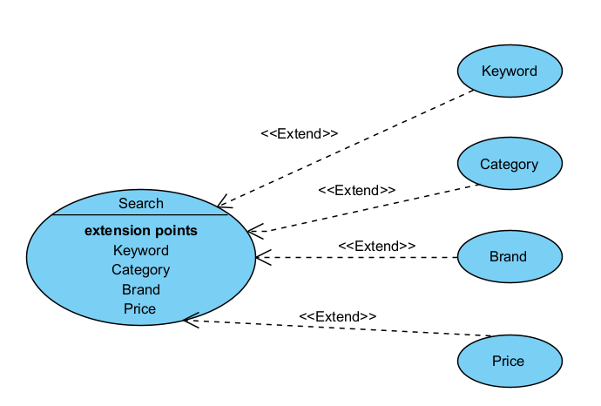

+Manage Order use case diagram:

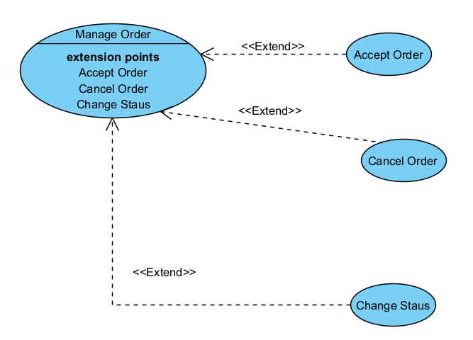

+Staff use case diagram:

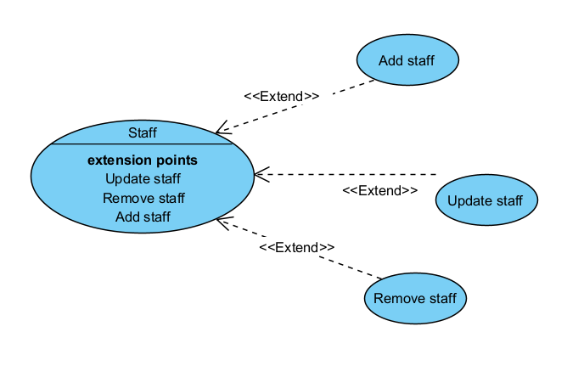

+Product management use case:

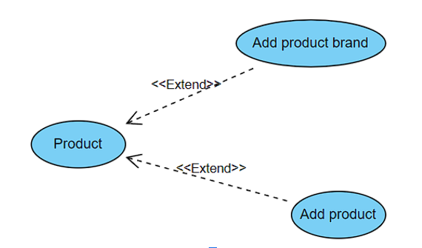

## Class Diagram

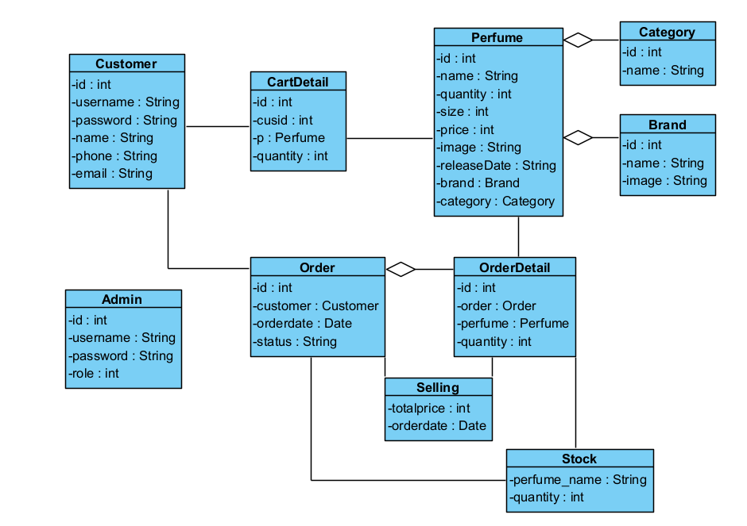

## Activity Diagram

*-Customer:*

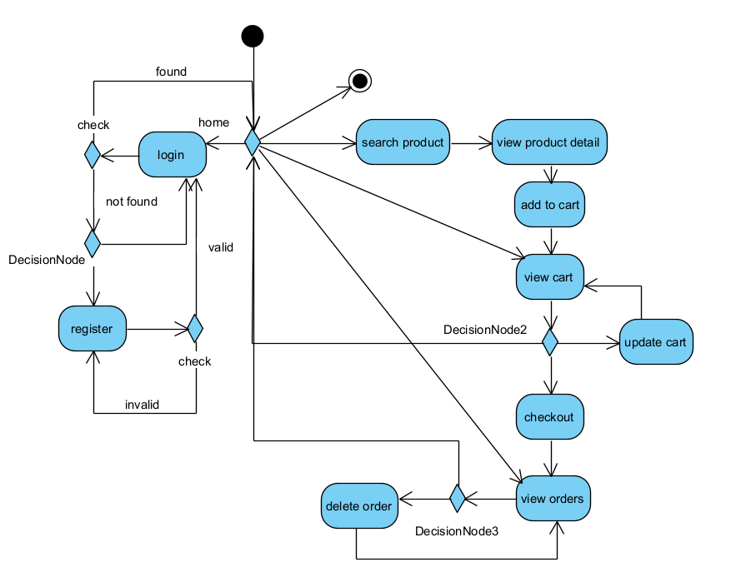

*-Admin*

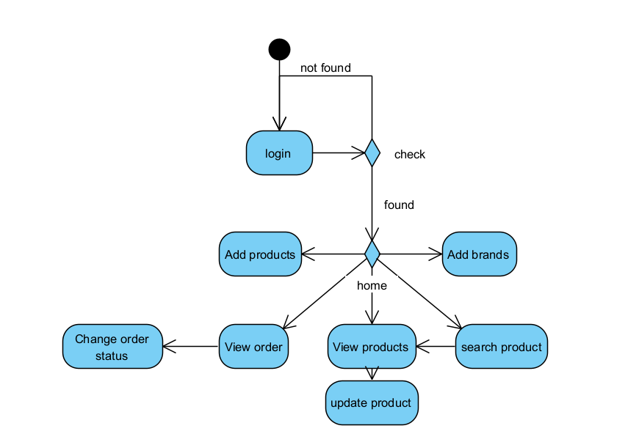

## Database Tables

### Table Customers

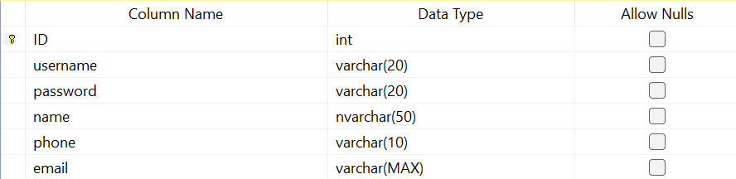

### Table Admins

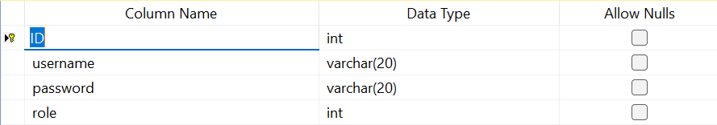

### Table Brands

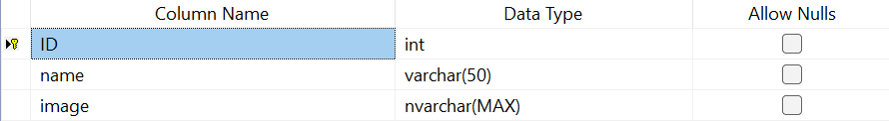

### Table Categories

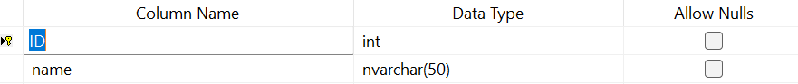

### Table Perfumes

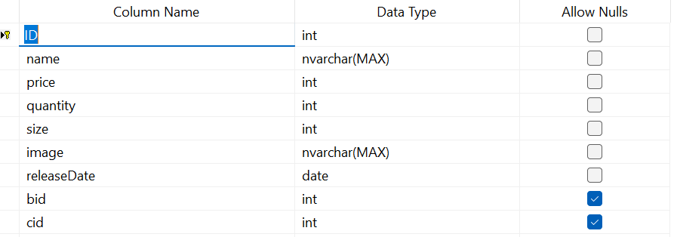

### Table CartDetails

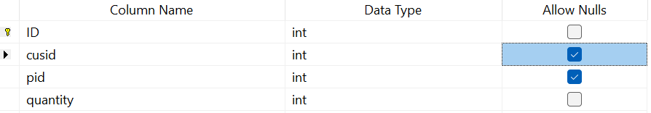

### Table Orders

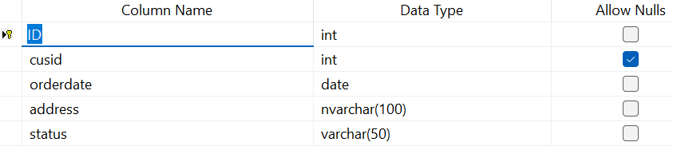

### Table OrderDetails

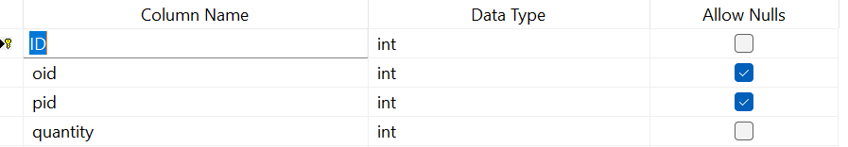

# Website Design

## Customer home interface

Home webpage does not require login. Here user can view all the brands, some perfumes which are new releases or top selling products. There is also a search bar for user to search the products.

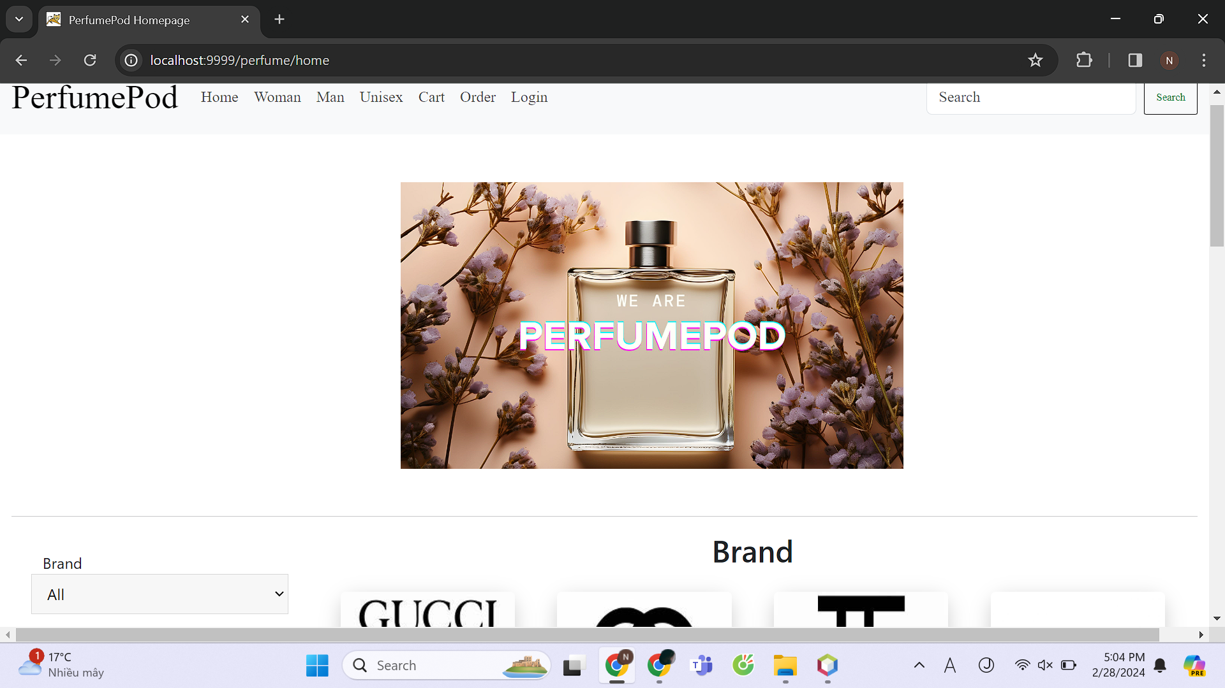

## Search bar template

The home search bar can help user to filter and search for the products. The filter consists of: Brand, category, price, date release

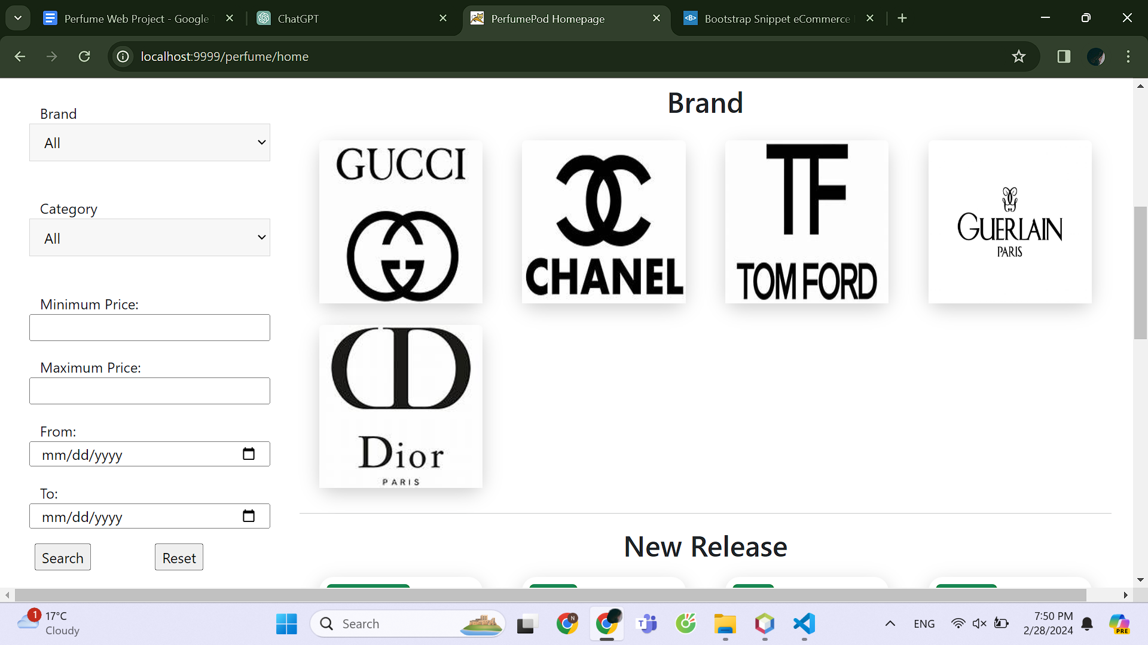

## Customer login interface

If the user wants to add cart, view order, check out, he needs to login first by entering his username and the password. If the user does not have account, he can click the register button to create new account.

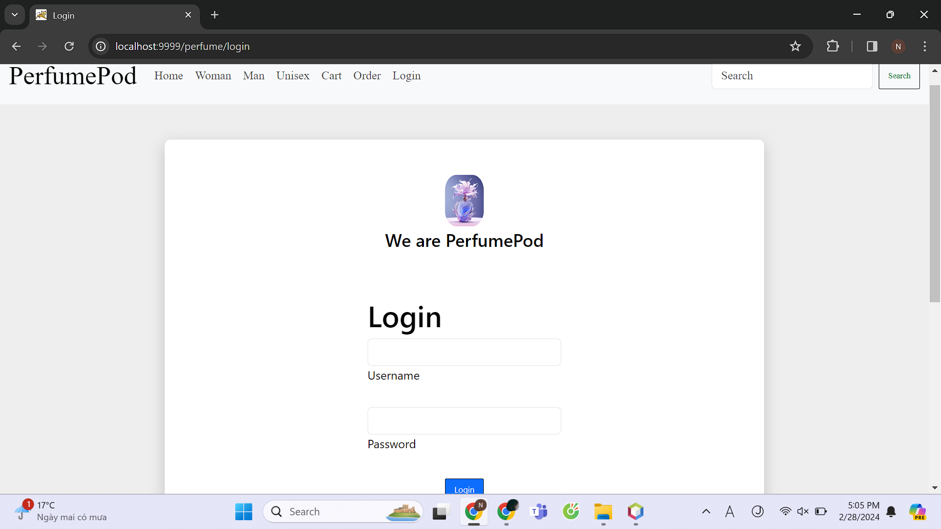

## Register interface

The user enters his username, password, name, phone, email. The system checks the input information then validates the new account for the user.

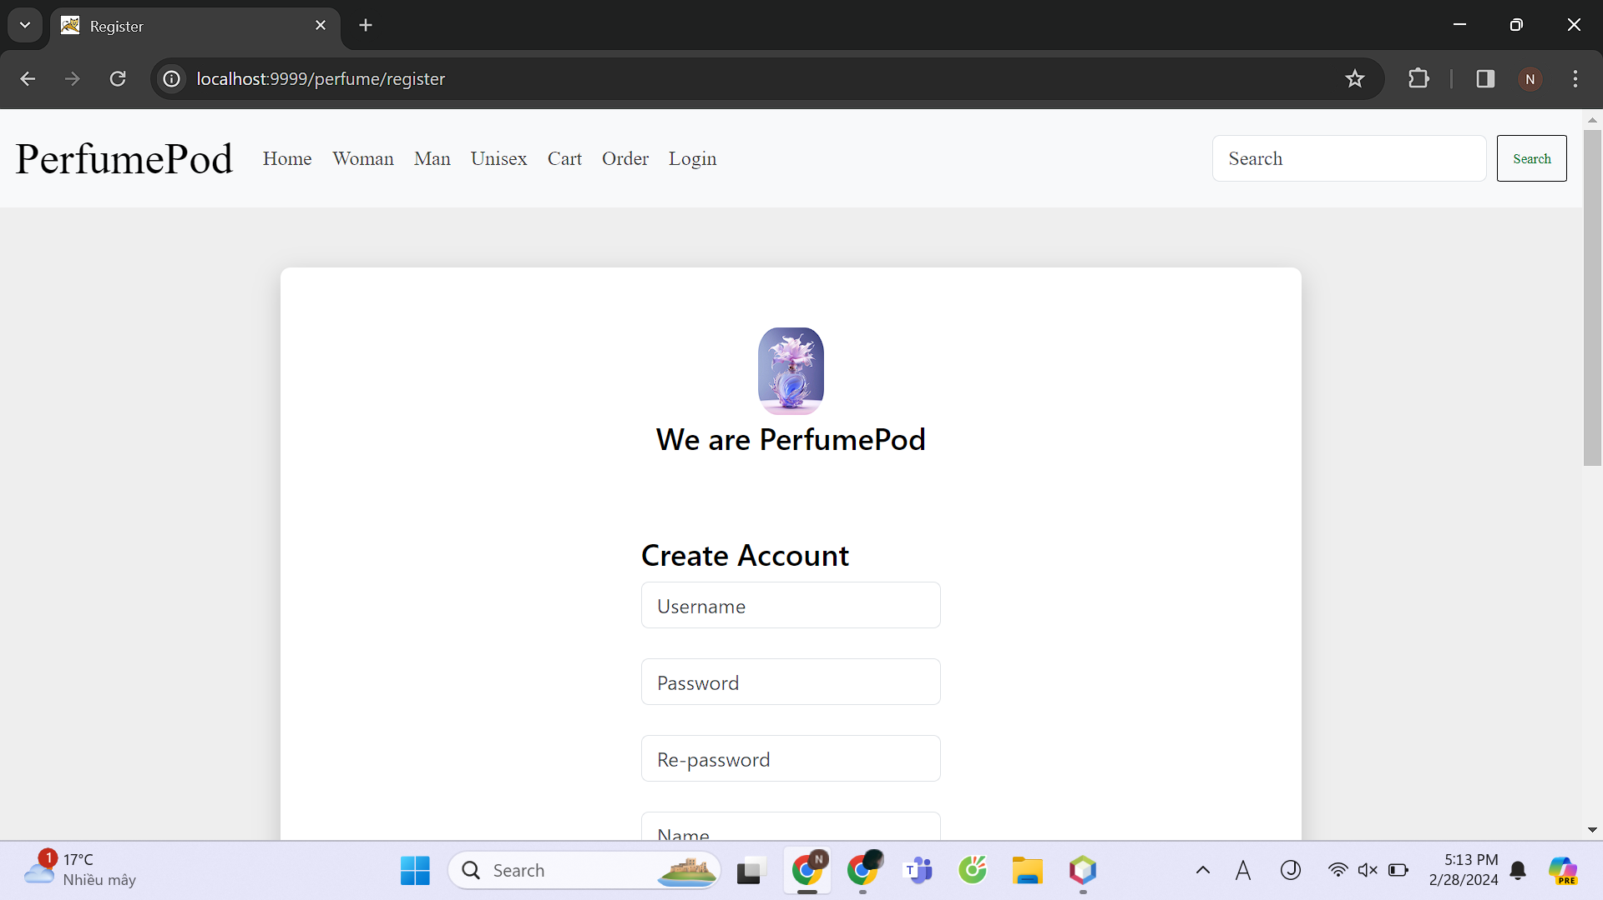

## Search product interface

The result of search in the search bar home or search (keyword) in the navbar header or when the user click for brand/category will be displayed in the search product webpage.

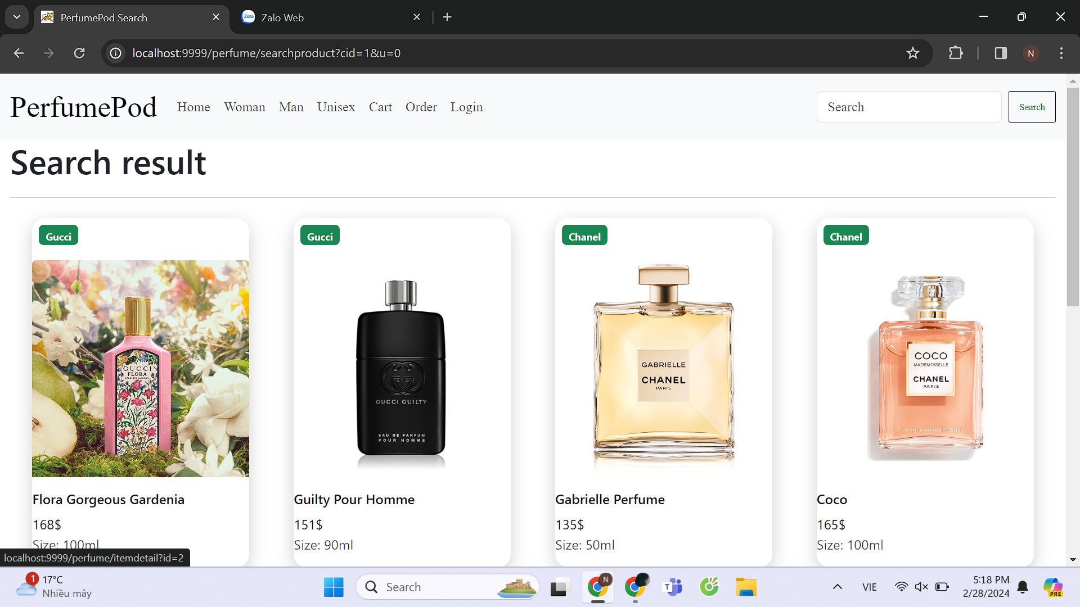

## Product detail interface

When the user clicks for the product, it detailed information will be displayed. The user then can add the products to cart (after login) or view its brand’s products.

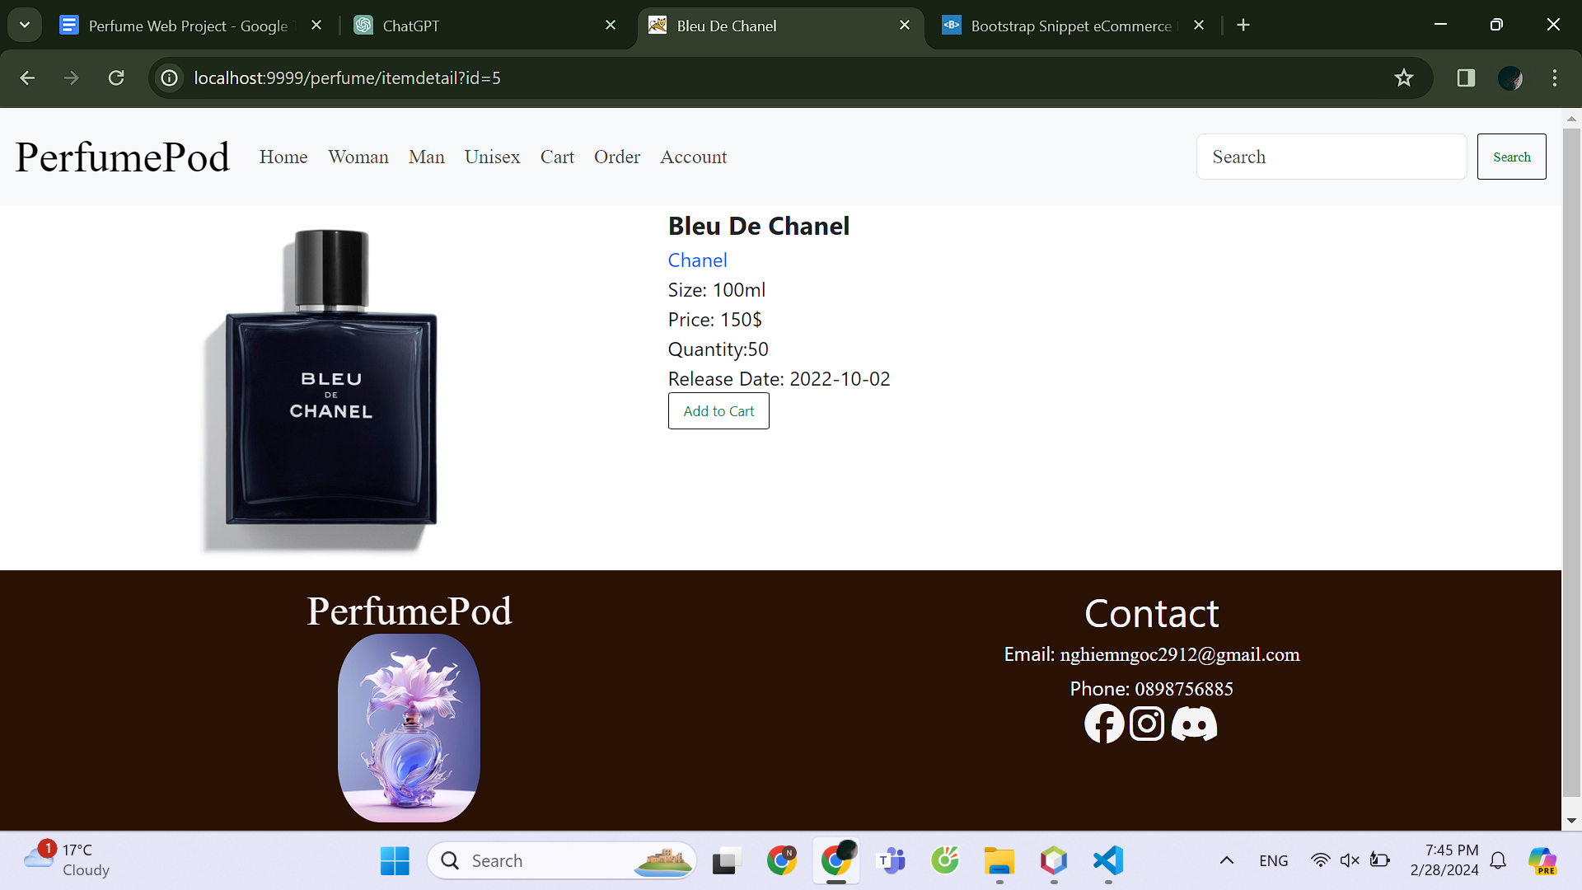

## Cart interface

The cart webpage displays the items that the user selected. The user can change the quantity of each item and get to know the total price. If the user wants to make order from the cart, he can click the checkout button

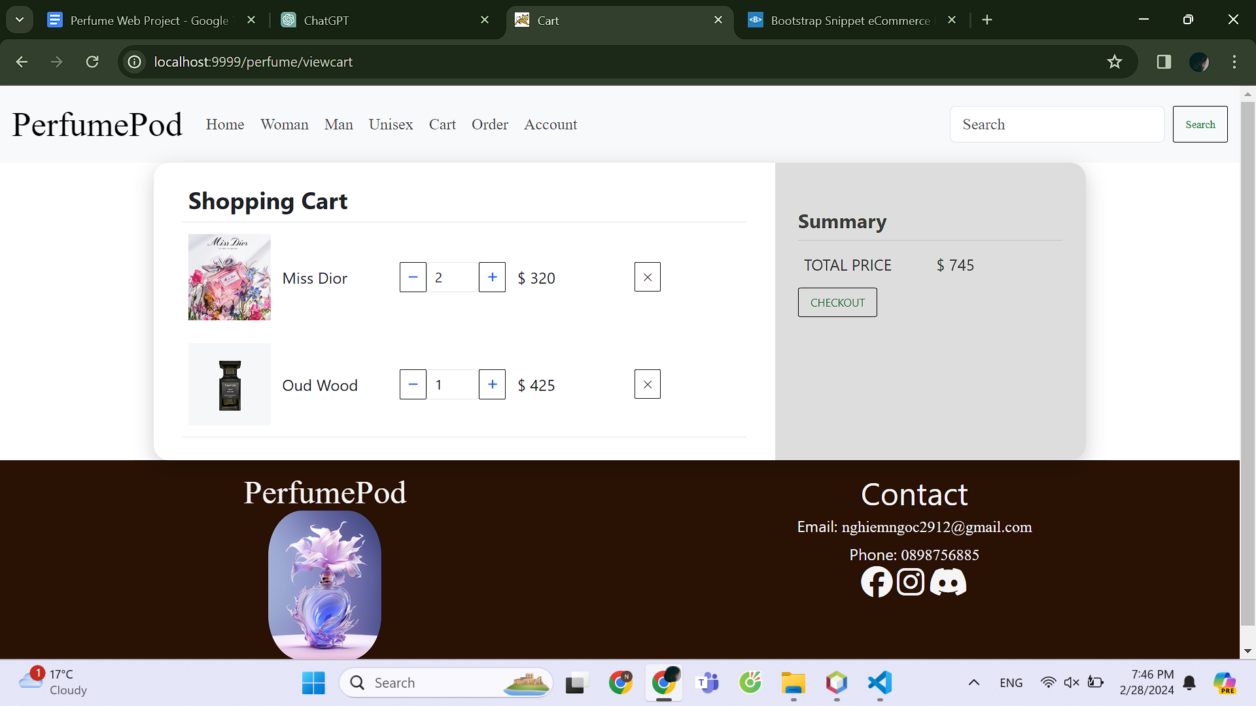

## Check out interface

The webpage displays the items and total price of the order. The user fill in the form of address and check location then check out.

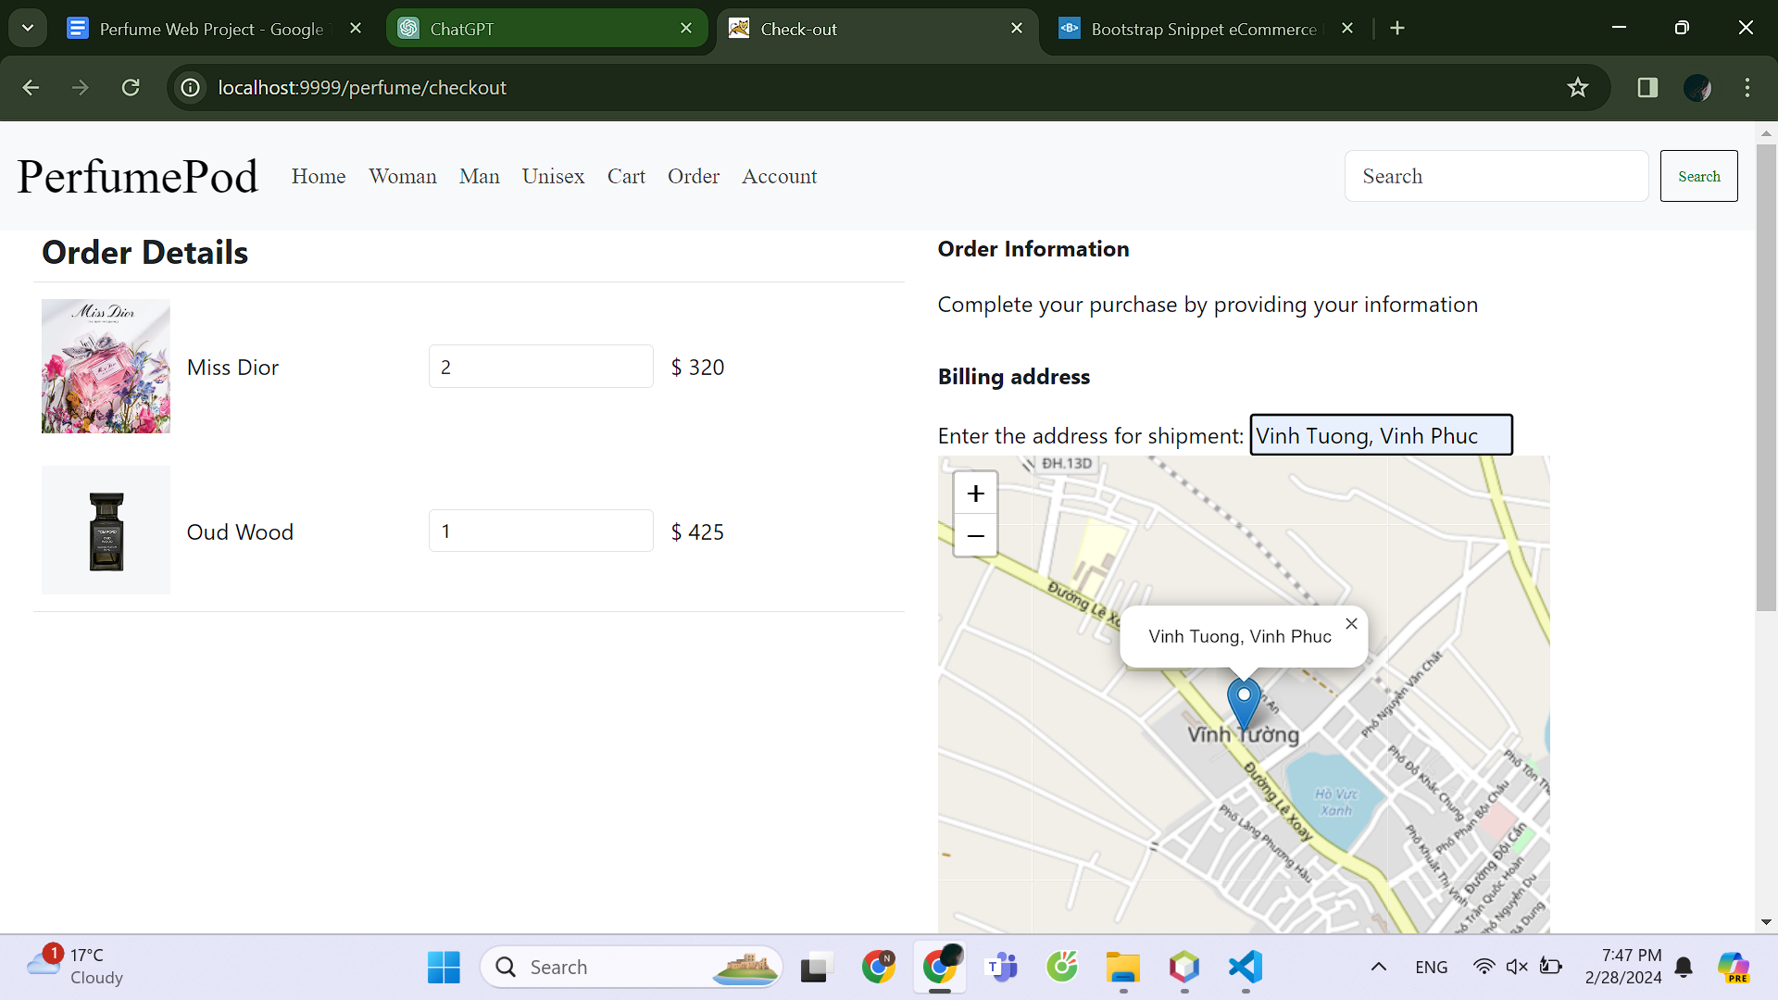

## Customer View Orders Interface

The webpage displays all orders of a user with the address, date, status.

If the order is confirming or denied, the user can delete that order.

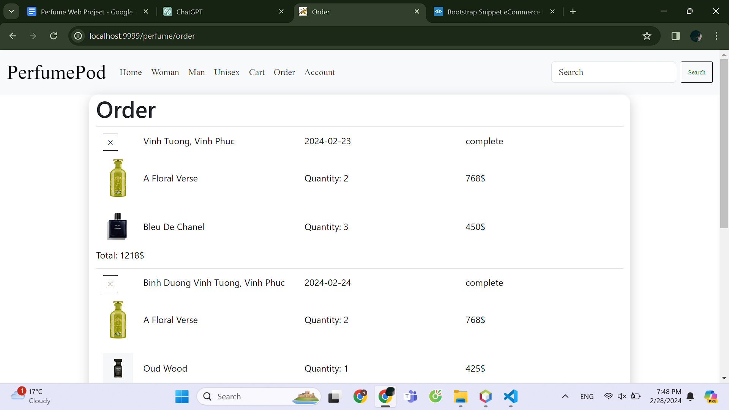

## Customer profile interface

The user clicks the account link in the header navbar to view his profile. He can update his information then click the Save button to Save. Moreover, the user can change password and logout.

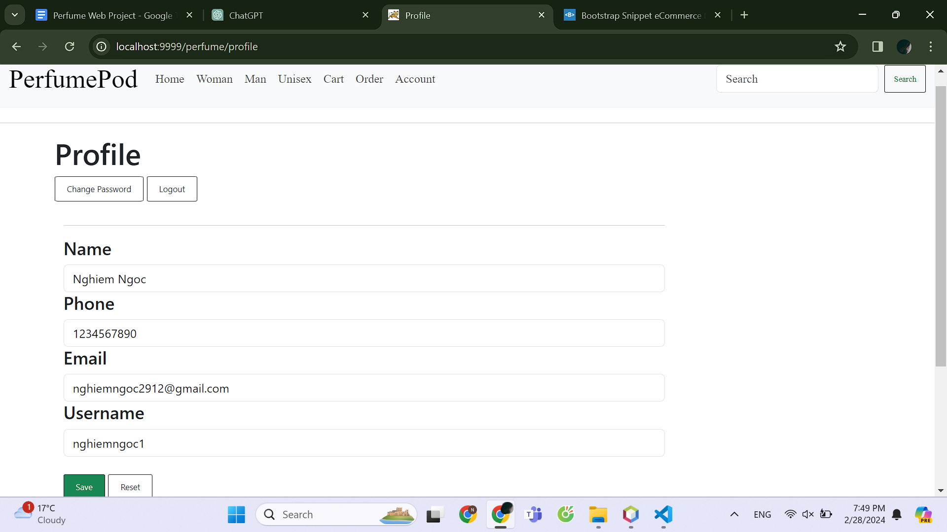

## Customer change password interface

The customer enters the old password and new password. After confirming, his password will be changed in the next login.

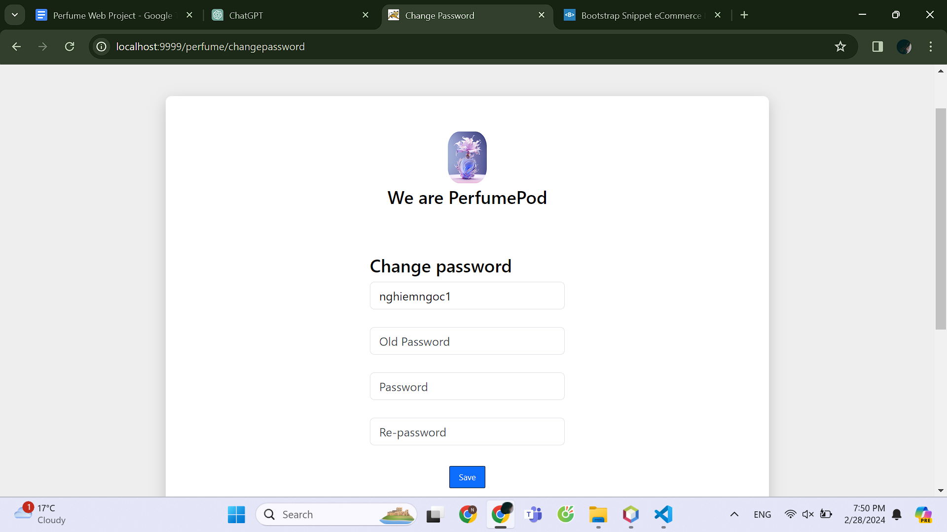

## Admin login interface

When a user wants to have admin role, he needs to be login as an admin by entering his username and password.

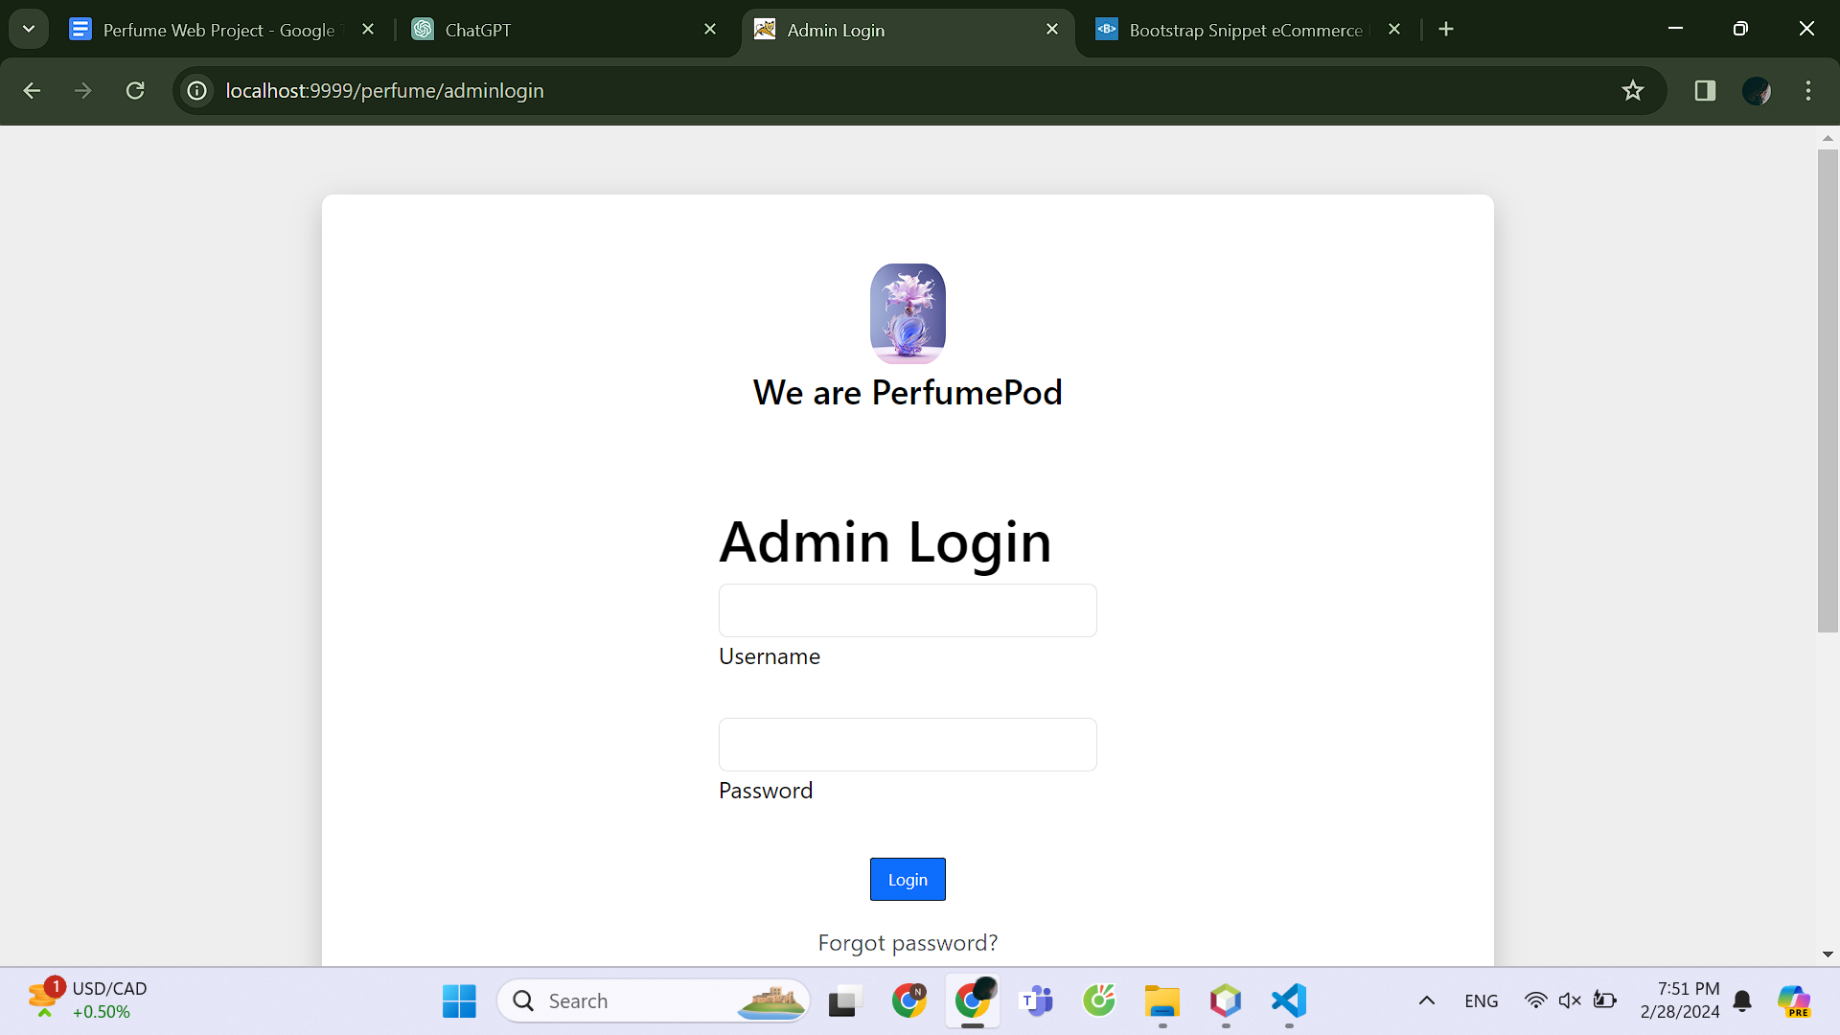

## Admin home interface

The admin home interface also has a navbar for product search and displays all the products and the the product update button.

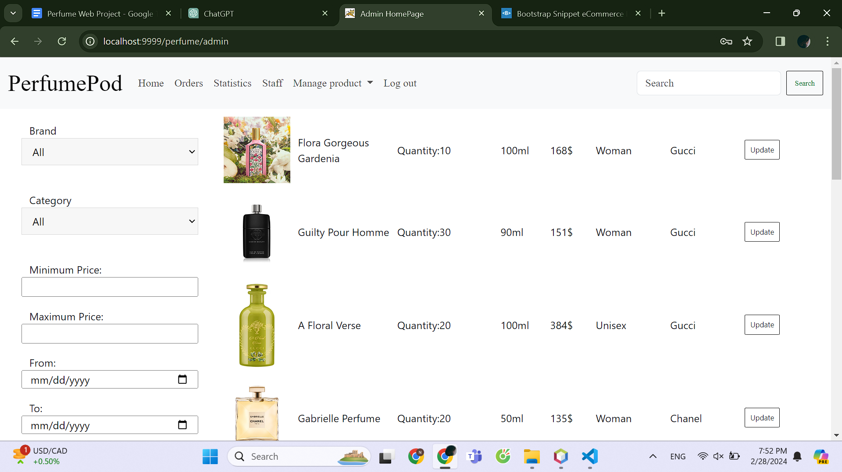

## Admin manage order interface

In default, the webpage displays all orders, or the user can select the orders with the status he want to find. The user can change the status of the order by clicking one of the status button above each order.

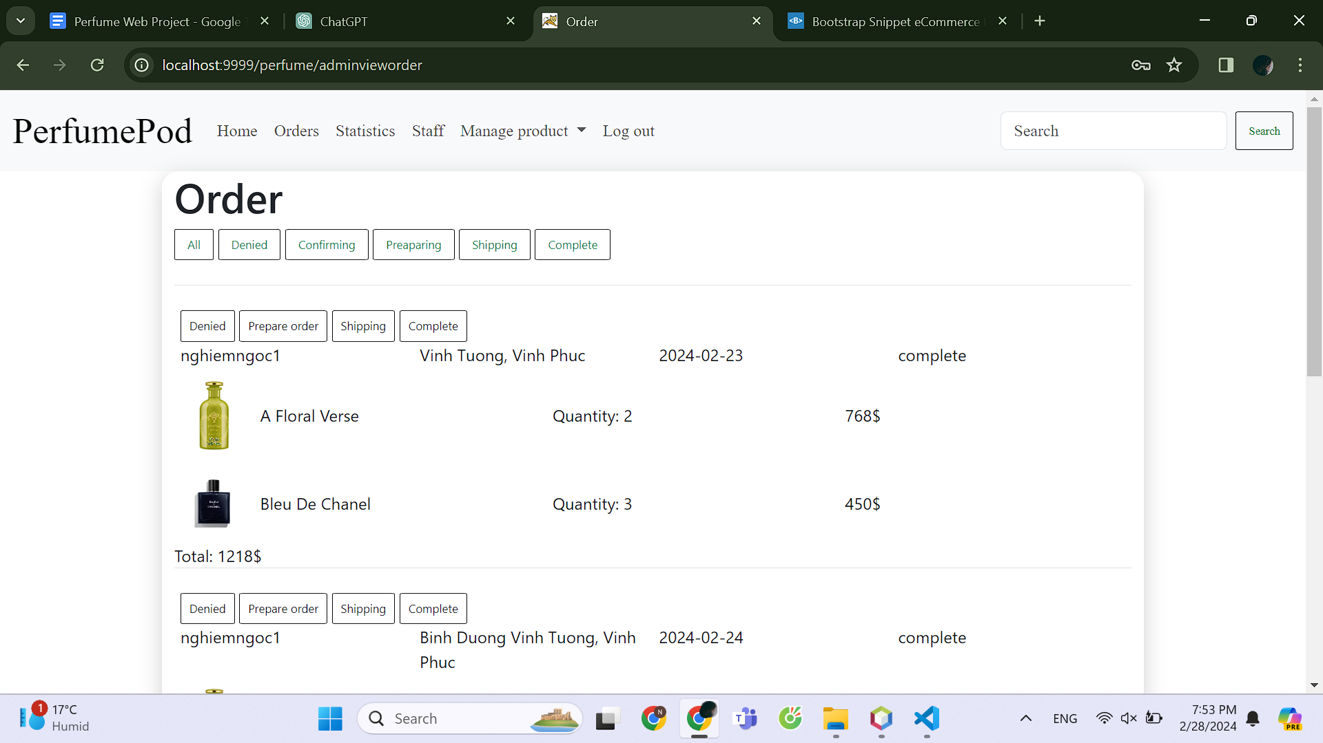

## Manager view statistic interface

The webpage shows the numbers of customers, products, total earning and complete order. It also has the bar chart of top selling perfume and the line graphs of total earning. Just manager can view this webpage.

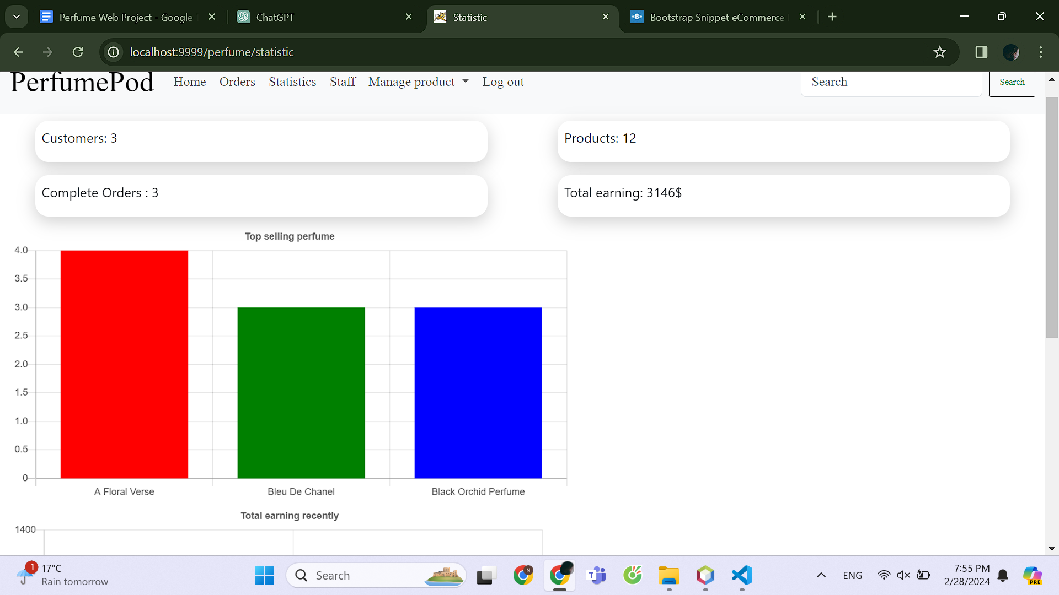

## Manager manage staffs interface

The manager views the staff, or delete and create new staff, and promote the staff to become a manager.

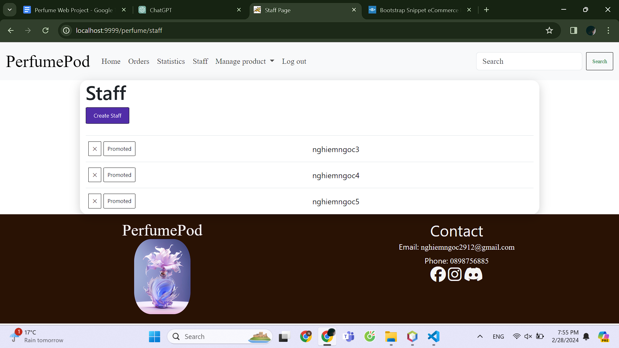

## Manager add staffs interface

The manager enters the required information, the system checks for it then validates new staff account.

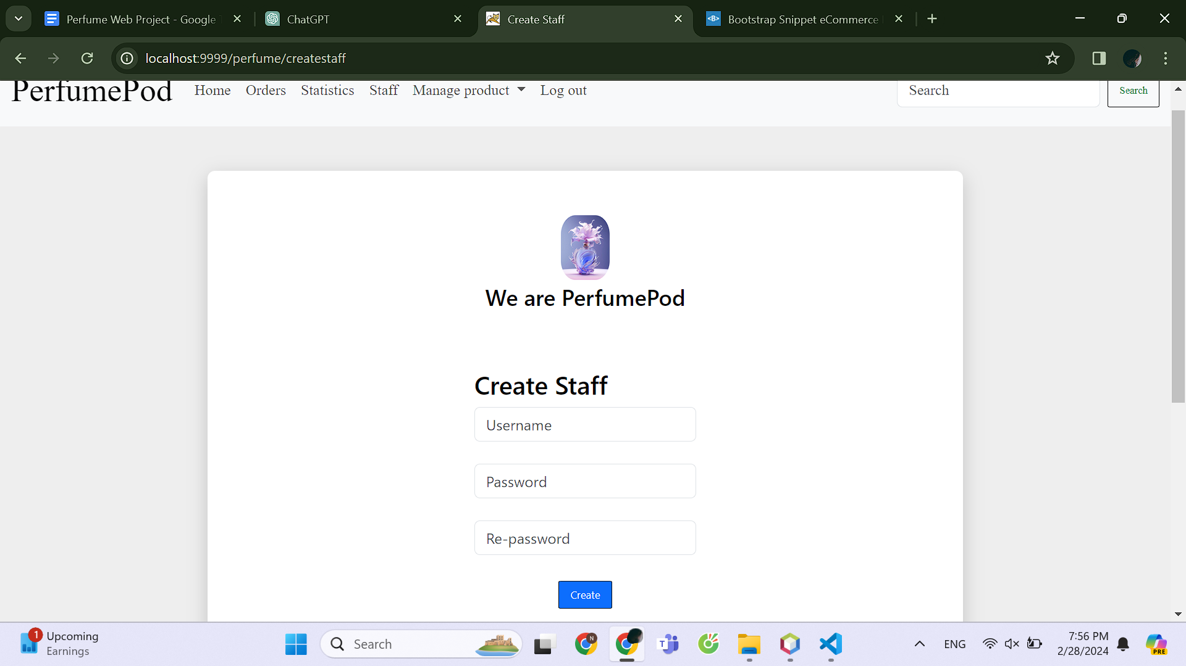

## Admin add perfume interface

The admin enters the attributes of the product to create new product.

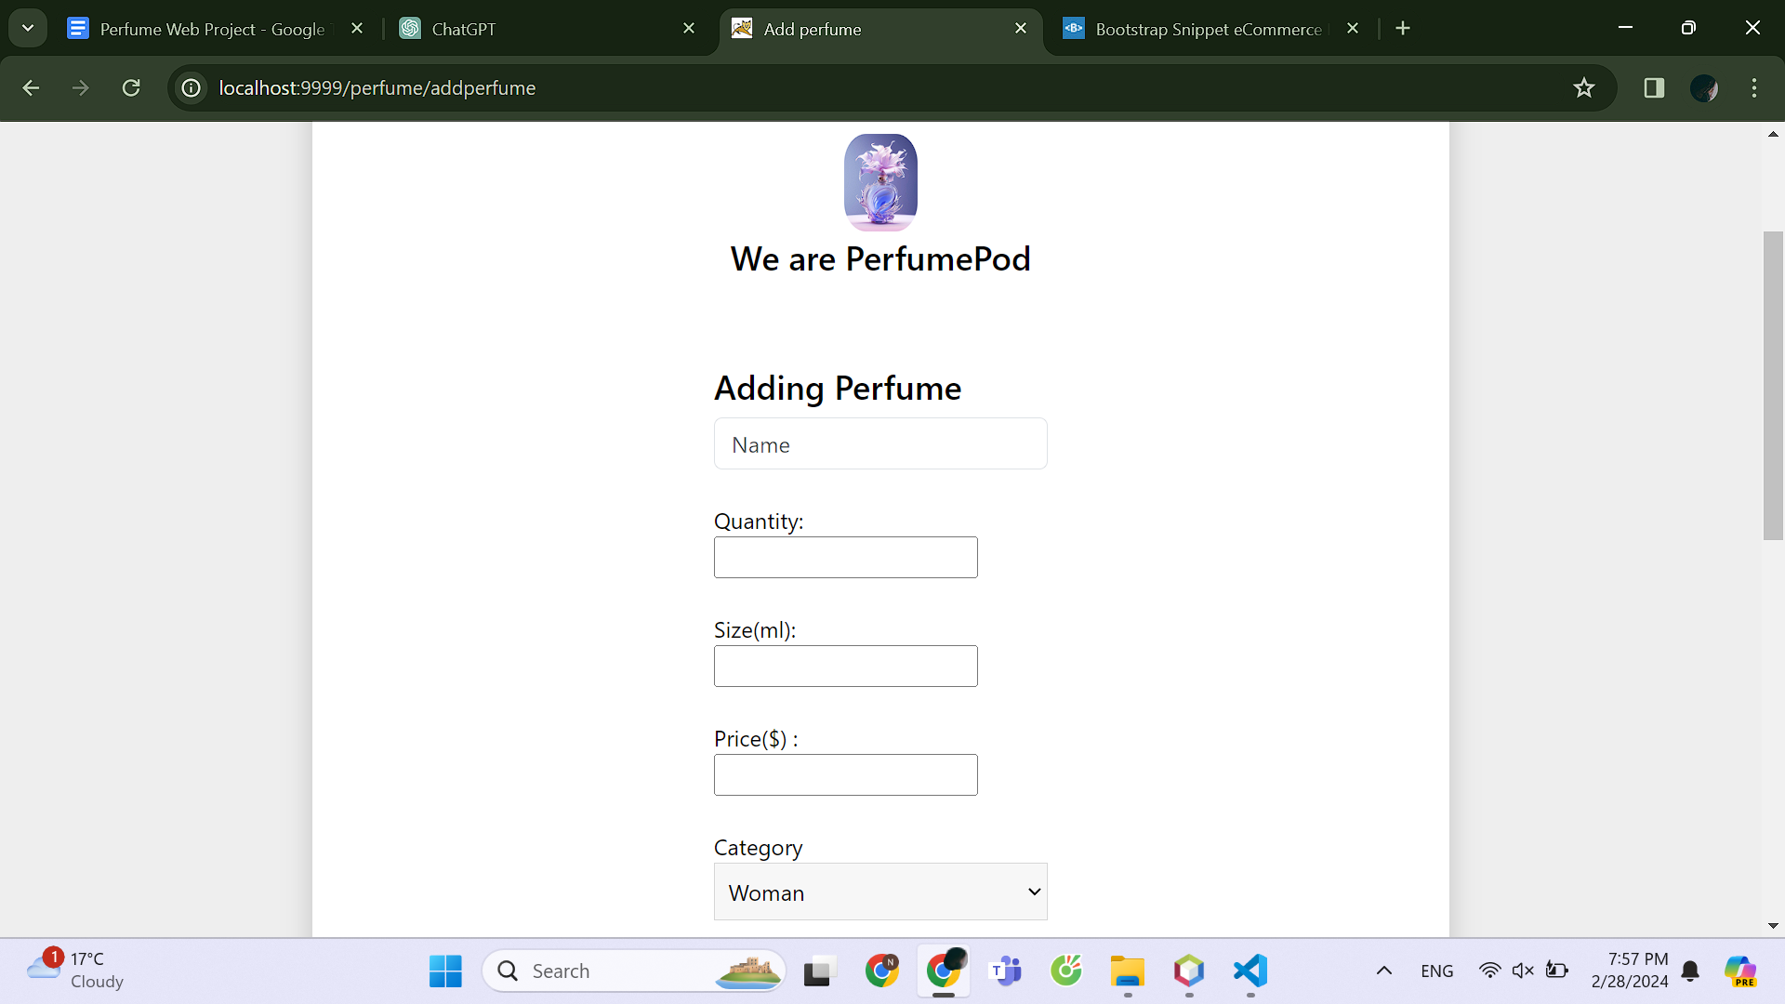

## Admin add brand interface

The admin enters the attributes of the brand to create new brand.

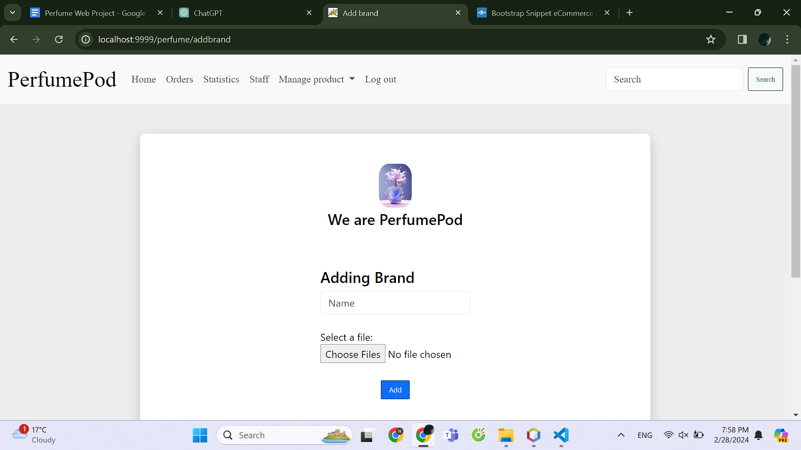

# Conclusion

-Achievements:

+The system partially meets the needs of computerizing the product promotion process for the store and building the customer's shopping cart, making it more convenient and saving time for both parties without reducing efficiency.

+The system has a simple interface according to the current trend, which is user-friendly and easy to use for both administrators and customers.

-Limitations:

+The system still has many shortcomings in both functionality and interface.

# References

[1] <https://www.w3schools.com/>

[2] <https://getbootstrap.com/>

[3] <https://chat.openai.com/>

[4] Perfume selling websites: <https://theperfume.vn/>, <https://namperfume.net/>, …